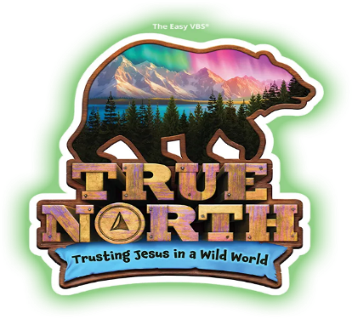
ADULT VOLUNTEER REGISTRATION
VACATION BIBLE CAMP 2025
June 16-20, 9:00am-12:00pm

Registrations are due by Friday June 6th
Click on each box to fill – save – and return by email to officeoffaithformation@stjoanofarc.org

Name:

Primary Phone:

Primary email:

T-shirt size: T-Shirt Sizes: Adult: S(34-36) M(38-40) L(42-44)

Emergency contact: Name/Relationship/Phone

I understand that still and/or video cameras will be used during many of the activities and may be used in future publications, posting, and/or on the St. Joan of Arc website. No names will be used.
I do hereby grant permission to have my picture taken during Vacation Bible Camp, 2025.

Signature/Date:

Adult volunteers are needed in many areas. Please check those that you are interested in helping with during the week of VBC or before.

Adult Station Leader for the week Help organize supplies

Aide to Station Leader for the week Other/ misc. help

Help decorate/ make decorations

Email completed form to: officeoffaithformation@stjoanofarc.org
Or mail or drop off at our office or the parish office.
496 E. Washington St, Chagrin Falls, OH 44022

